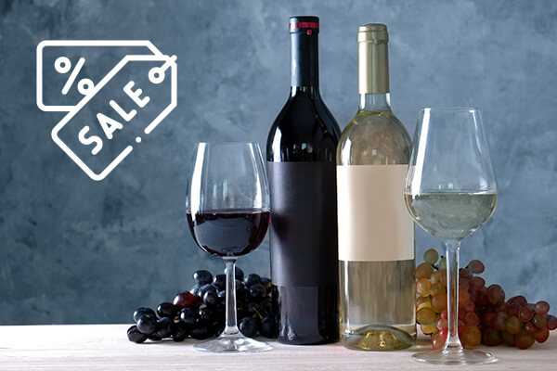

**Time Series Analysis for Australian Wine Sales**

**Summary**

In this project we explore the 3 Australian Wine selections. The data in this set ranges from 1980 to 1994. We chose to explore the red, sparkling, and sweet white wines. This data is used for forecast monthly wine sales into the upcoming year. In this we are going to analyze red, sparkling, and sweet white wine. When we visualize all the three wines, red wine has an upward linear trend and seasonality, Sparkling wine has a constant trend and large seasonality and sweet white wine has a downward trend from 1980 and has a peak in 1985 and thereafter decreasing from 1990. When we checked for the predictability of all the three wines by AR(1) model and then doing a hypothesis testing, all of their null hypotheses were rejected. It proves that the data is not a random walk and is predictable into the future.

Regression based models, advanced exponential smoothing models, Holt-Winters model and autoregressive integrated moving averages model were utilized in this project. The regression models were enhanced with a trailing moving average for residuals and auto regression models for residuals. For choosing the best model, the model evaluation is based on RMSE and MAPE accuracy metrics. The best model we found to use for our data set is Holt-Winters with a lower average RMSE and MAPE compared to the ARIMA and two-level models. We then compared the full data set models to the naive model as well as the seasonal naive model to see if the models that we generated were better than the naive and seasonal forecasts.

**Introduction**

Wine has been an important industry in Australia for many years, with the country producing a wide variety of wines that are enjoyed both domestically and internationally. The period from 1980 to 1994 was an important time for the Australian wine industry, with significant changes taking place during this time.

The data in this set ranges from 1980 to 1994. We explore red, sparkling, and sweet white wine.

The analysis of Australian wine sales from 1980 to 1994. The information from this period gives important experiences into the factors that have added to this development and can be utilized to figure future patterns.

During the 1980s and 1990s, the Australian wine industry underwent significant growth, with many new grape varieties being introduced and winemaking techniques improving. This growth led to an increase in exports of Australian wine, which helped to boost the country's overall trade balance.

According to the Australian Bureau of Statistics, the value of wine exports from Australia increased from $52 million in 1985 to $1.8 billion in 1996. This demonstrates the significant impact that the wine industry had on the Australian economy during this time period.

Overall, while we do not have exact figures for the contribution of the Australian wine industry to the GDP during the 1980s and 1990s, it is clear that this industry played an important role in the country's overall economic growth during this period.

The Australian wine sales data set includes data for the volume of wine sales, the worth of sales. The scope of this project is to forecast wine sales by using various time series models to analyze the monthly data output of the Australian wine industry. This will greatly aid the businesses involved in staying on top of vague trends and changes in consumer preferences while planning for the future with an eye towards the past.

**Eight Steps of Forecasting:**

**Step 1: Define Goal**

The goal of this project is to create forecasts of the Australian wine sales for the future period. The objective is to create a predictive model Where we consider the trend and seasonality components of the data to forecast the future year. Since the data has three wines, we are going to create a separate Time series for all the three wine’s and create different models for different Time series. The best forecast will be chosen by comparing all the models for the resulting future forecast.The forecasting models developed for this project were done via the R language.

**Step 2: Get data**

This report will focus on the time series dataset provided by the Australian Bureau of Statistics recording the monthly wine sales measured in liters by the wine industry. The time period for the dataset ranges from 1980 to 1994 but for the purposes of this project we chose to explore the red, sparkling, and sweet white wines.

**Step 3: Explore and Visualize Series**

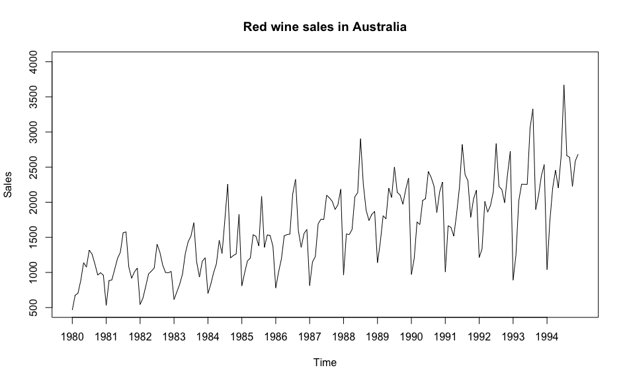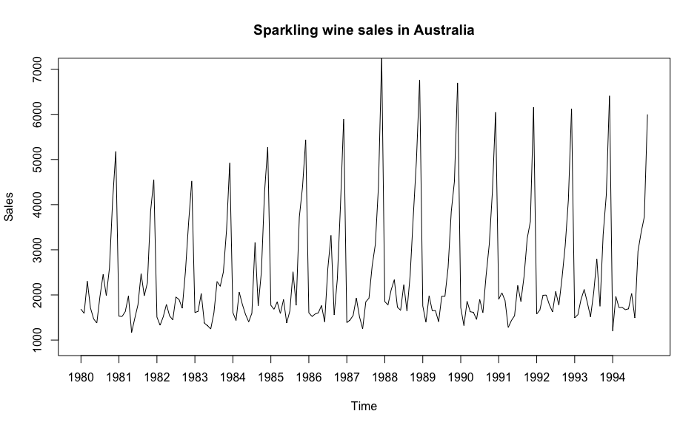

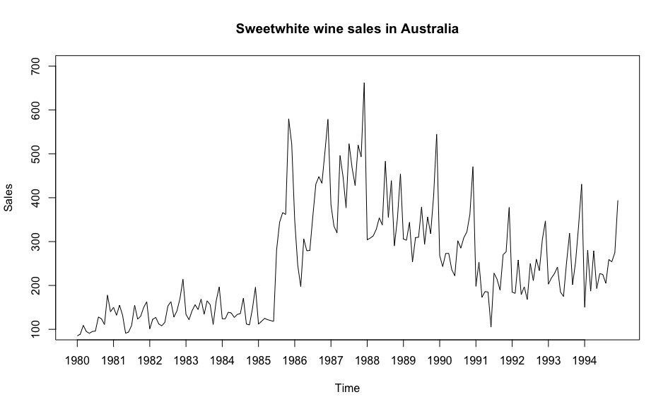

The data plots of all the three wines are shown above. The red wine time series has an upward linear trend with seasonality. The sparkling wine time series has a Constant trend with seasonality, it peaked in the year 1987 and then went back to normal. The sweet wine time series has a low trend in the beginning, it has an increase from the year 1985 and thereafter after decreasing trend from 1990.

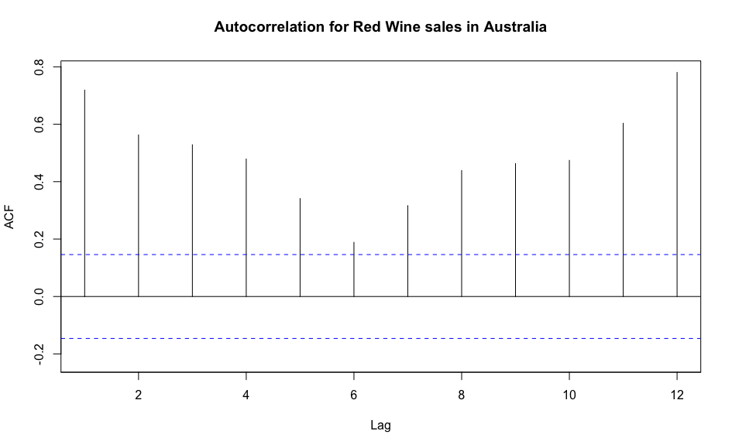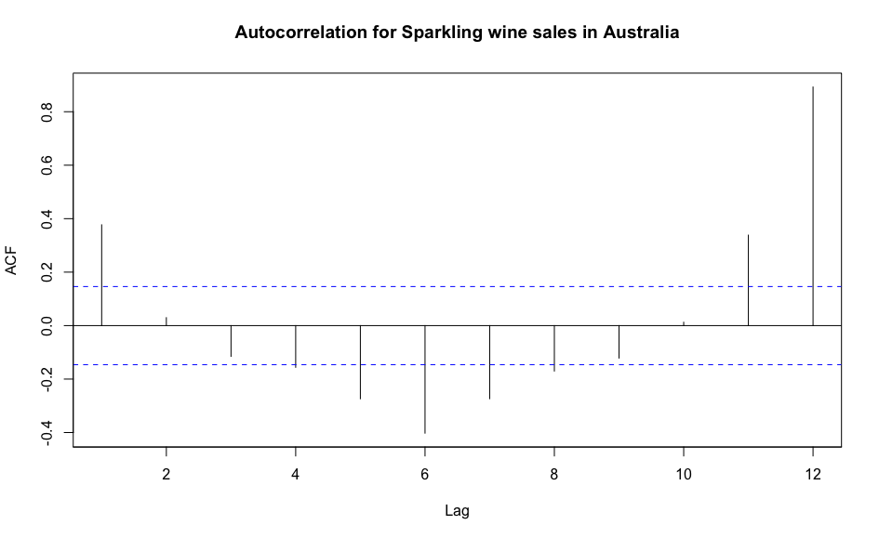

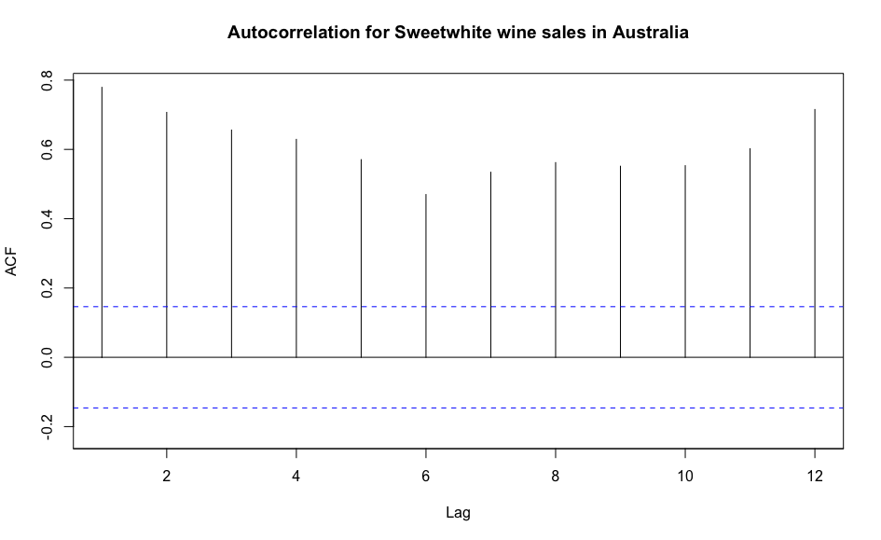

From the autocorrelation charts above we can see that all three wines data are highly correlated, the autocorrelation coefficients in all the wines are higher than the upper threshold (significantly greater than zero). It proves that they are statistically significant at almost all lags in the autocorrelation. When we look at the autocorrelation of sparkling wine it still is statistically significant as most of its lags are above and below the threshold..

**Step 4: Data Preprocessing**

The original data from the Australian Bureau of Statistics contains 6 different wines; they are fortified, red, rose, sparkling, sweet white, dry white in the excel spreadsheet. For the purpose of this project we only took red, sparkling, sweet white was the only sheet, which was kept, the rest were deleted. The other wine production columns, one with incomplete data and one with complete data. Naturally, the complete columns were chosen. Next, three separate time series datasets were created, one with red wine, one with sparkling wine and the sweet white second with 15 years of data (1980-1994). The amount of observations per series are 180 per each time series, respectively.

**Step 5: Partition Series**

We created a data partition of 144 records for the training period and 36 records for the validation period for all the three wines. These partitioned validation and training data sets splits are shown in figure 1 of the appendix.

**Step 6 & 7: Apply Forecasting & Comparing Performance**

**Forecasting for Training data**

1. Two level with linear trend + seasonality regression and AR(1) model for regression residuals into Training Data.

Linear trend and seasonality regression.

Below is the output for the Linear trend and seasonality regression for the red wine series.

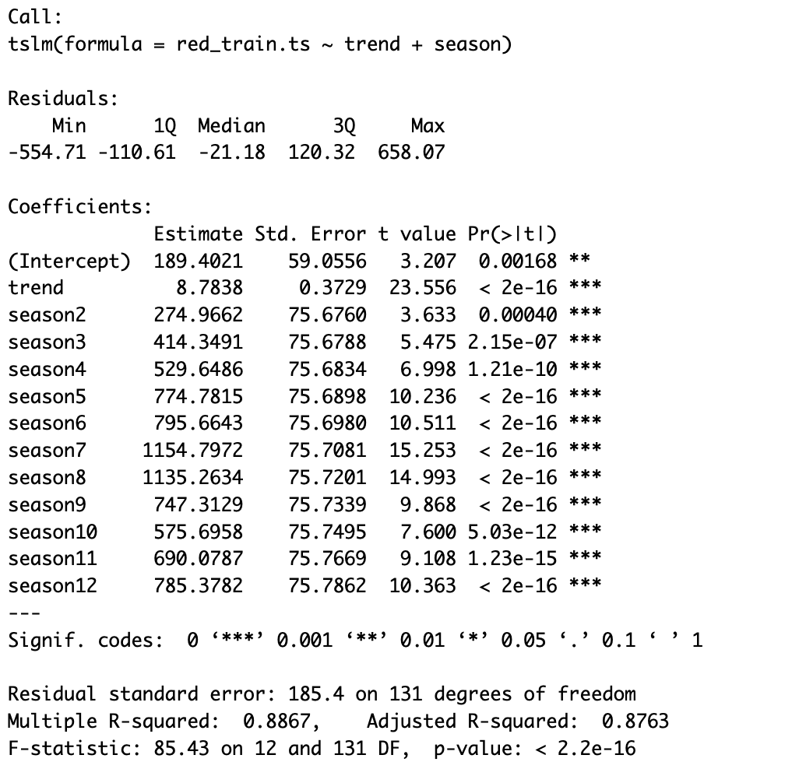

For the red wine , the model above represents a regression model with linear trend and seasonality. The model is statistically significant since the F-Statistic p-value is very low (2.2e- 16), much lower than an alpha of 5%. The R-Square of the model is 88.67%, it is closer to one meaning it is statistically significant. The adjusted R-square of the model is 87.63%. These predictors are all significant since their p-values are lower than an alpha of 5%.

Below is the output for the AR(1) Model for the red wine series.

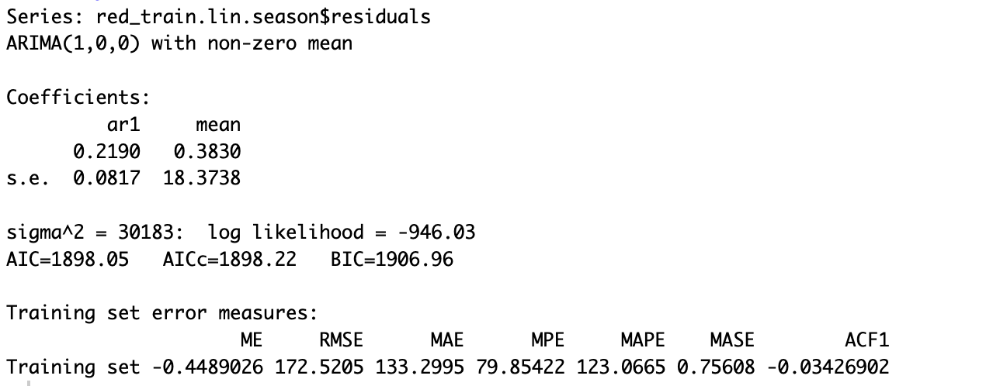

For the red wine series, the AR(1) function was used to create an autoregressive model using the residuals for the regression with linear trend and seasonality. The model coefficient for AR1 model is 0.2190 and model intercept is the mean value of 0.3830.

Below is a compiled summary of the red wine series autocorrelation charts representing the training residuals and the training residuals of residuals.

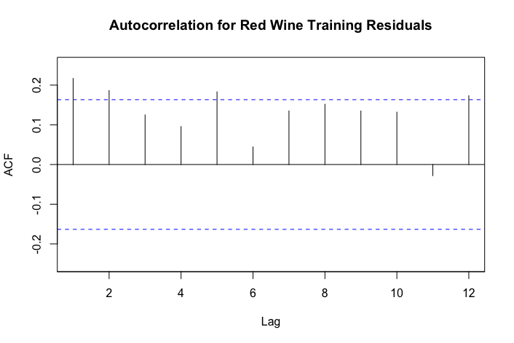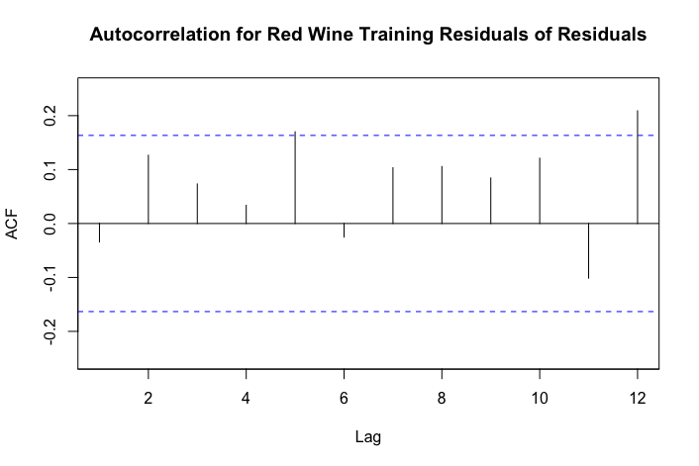

A table of validation data regression forecast, AR(1) forecast and combined forecast for red wine is presented in figure-2 of the appendix.

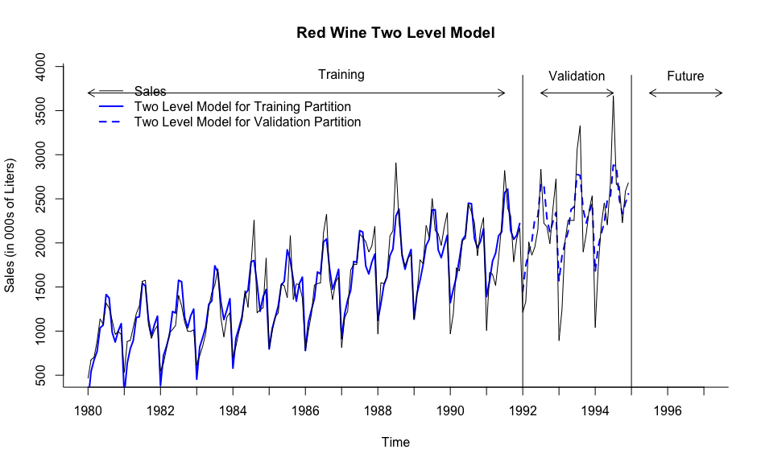

Above is the plot of red wine for the two level model with linear trend + seasonality regression and AR(1) model for regression residuals into Training Data and Validation data.

Below are the accuracies rounded to 2 using the function accuracy() in R

|  |  |  |
| --- | --- | --- |
| Model | RMSE | MAPE |
| Two level model forecast | 319.85 | 14.04 |
| Seasonal Naive forecast | 270.78 | 12.26 |
| Naive forecast | 445.81 | 22.46 |

1. Holt-Winters Model for training data.

Below is the output for the Holt-Winter Model for the red wine series.

The following summary represents the values of the smoothers of the Holt-Winters Model. Holt-Winters Models selected a model with multiplicative error, additive trend and multiplicative seasonality with Smoothing parameters alpha of 0.141, beta of 1e-04 and gamma of 1e-04.

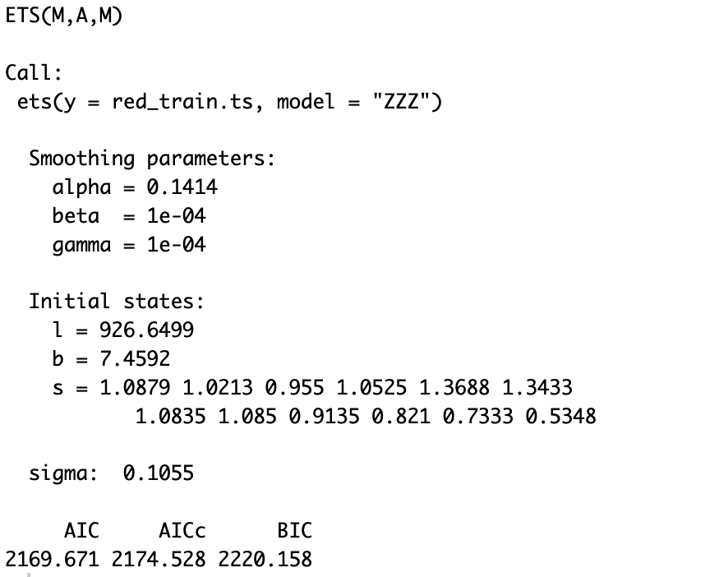

The below are accuracy metrics of the holt-winter model rounded to 3.

|  |  |  |
| --- | --- | --- |
| Model | RMSE | MAPE |
| Holt-Winter model | 280.076 | 10.693 |

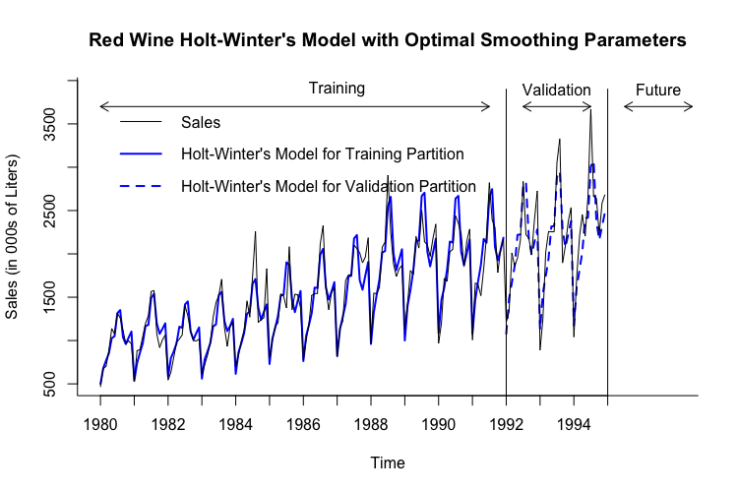

Above is the plot for the Holt-winter model into Training Data and Validation data.

1. Auto ARIMA Model for training data.

Below is the output for the Auto ARIMA Model for the red wine series.

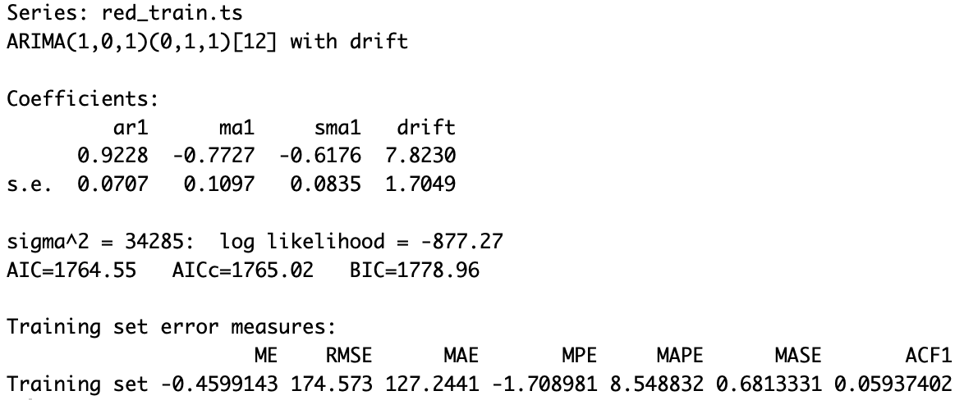

The red wine series coefficients consist of a AR-1 coefficient, moving average lagged 1 period, and 1 seasonal moving average lagged 1 with values of: 0.9228, -0.7727, -0.6176 respectively.

|  |  |  |
| --- | --- | --- |
| Auto ARIMA for Red wine | | |
| p | 1 | order 1 autoregressive model |
| d | 0 | order 0 differencing to remove linear trend |
| q | 1 | order 1 moving average (MA1) model for error lags. |
| P | 0 | order 0 autoregressive model for seasonality. |
| D | 1 | order 1 differencing to remove linear trend |
| Q | 1 | order 1 moving average (SMA1) model for error lags |
| m | [12] | For monthly seasonality. |

The below are accuracy metrics of the Auto-ARIMA model rounded to 3.

|  |  |  |
| --- | --- | --- |
| Model | RMSE | MAPE |
| Auto-ARIMA model | 280.172 | 10.502 |

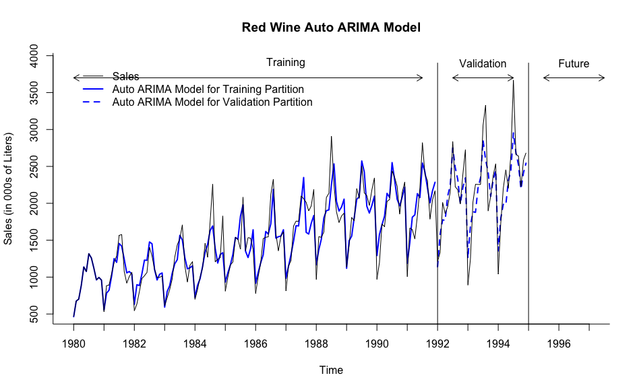

Above is the plot for the Auto-ARIMA model into Training Data and Validation data.

1. Two level with linear trend + seasonality regression and AR(1) model for regression residuals into Training Data.

Linear trend and seasonality regression.

Below is the output for the Linear trend and seasonality regression for the sparkling wine series.

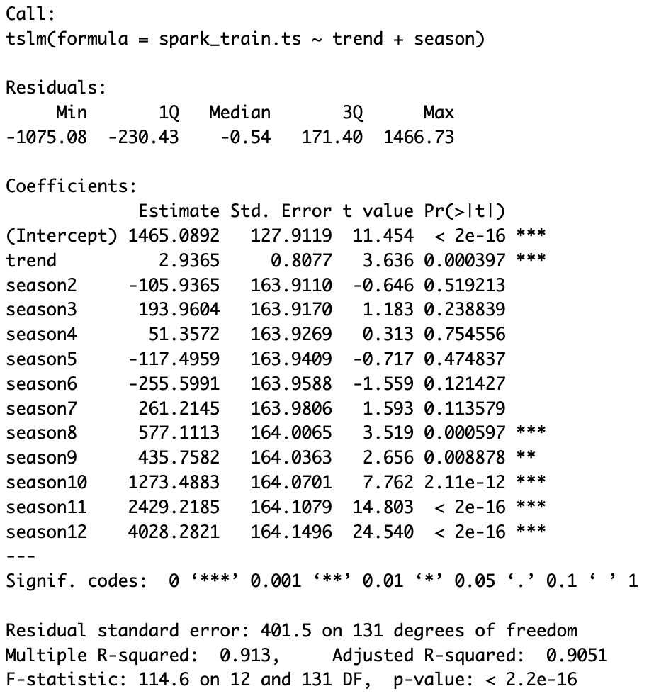

For the sparkling wine , the model above represents a regression model with linear trend and seasonality. The model is statistically significant since the F-Statistic p-value is very low (2.2e- 16), much lower than an alpha of 5%. The R-Square of the model is 91.3%, it is closer to 100% meaning it is statistically significant. The adjusted R-square of the model is 90.51%. These predictors are all significant since their p-values are lower than an alpha of 5%.

Below is the output for the AR(1) Model for the sparkling wine series.

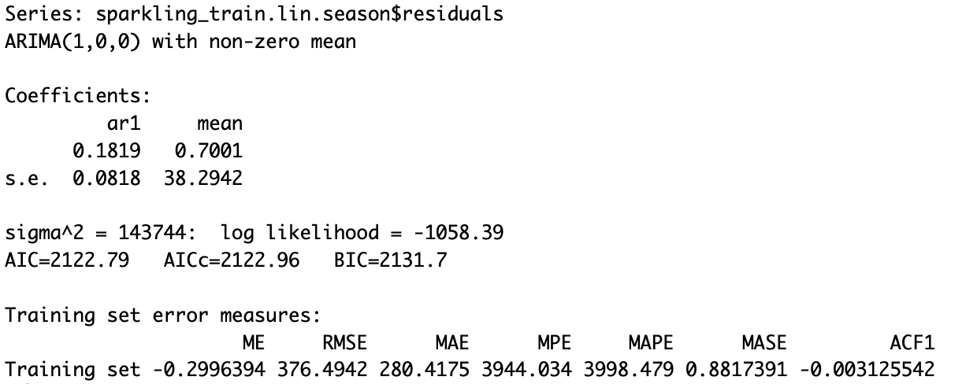

For the sparkling wine series, the AR(1) function was used to create an autoregressive model using the residuals for the regression with linear trend and seasonality. The model coefficient for AR1 model is 0.1819 and model intercept is the mean value of 0.7001.

Below is a compiled summary of the spa wine series autocorrelation charts representing the training residuals and the training residuals of residuals.

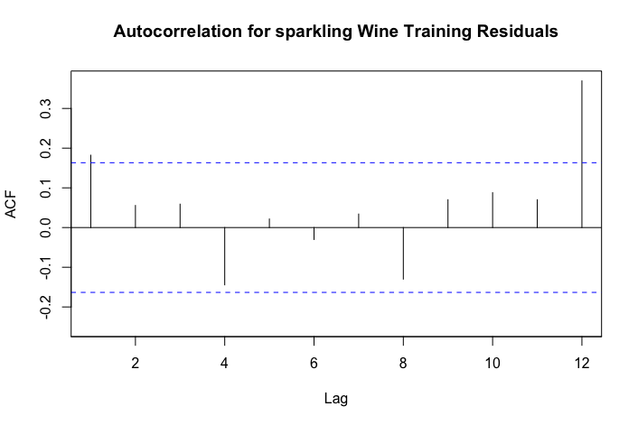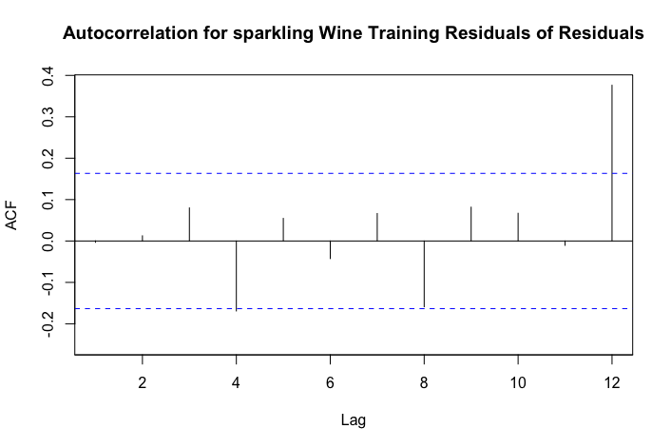

A table of validation data regression forecast, AR(1) forecast and combined forecast for sparkling wine is presented in figure-3 of the appendix.

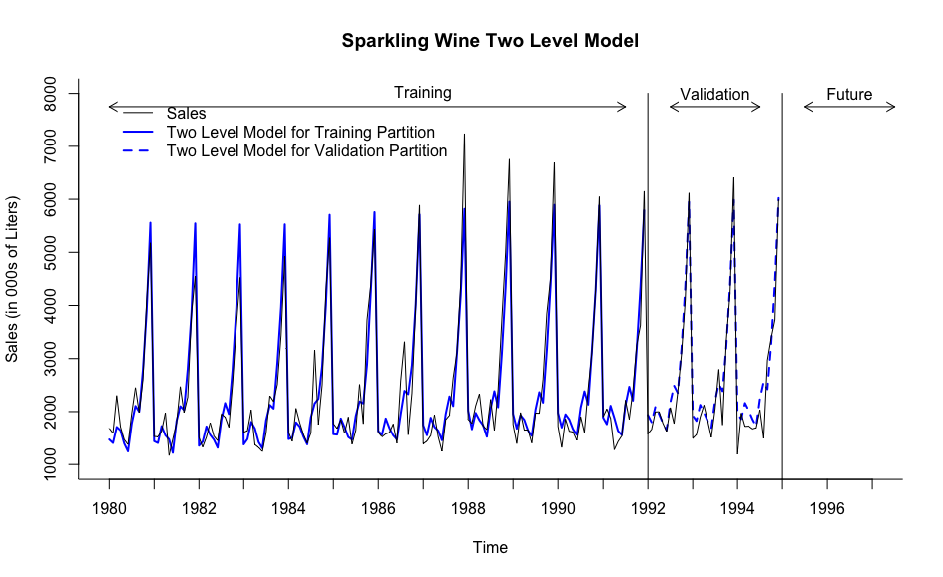

Above is the plot of sparkling wine for the two level model with linear trend + seasonality regression and AR(1) model for regression residuals into Training Data and Validation data.

Below are the accuracies rounded to 2 using the function accuracy() in R

|  |  |  |
| --- | --- | --- |
| Model | RMSE | MAPE |
| Two level model forecast | 362.97 | 13.57 |
| Seasonal Naive forecast | 429.52 | 13.85 |
| Naive forecast | 1436.97 | 41.20 |

1. Holt-Winters Model for training data.

Below is the output for the Holt-Winter Model for the sparkling wine series.

The following summary represents the values of the smoothers of the Holt-Winters Model. Holt-Winters Models selected a model with multiplicative error, no trend and multiplicative seasonality with Smoothing parameters alpha of 0.062 and gamma of 1e-04.

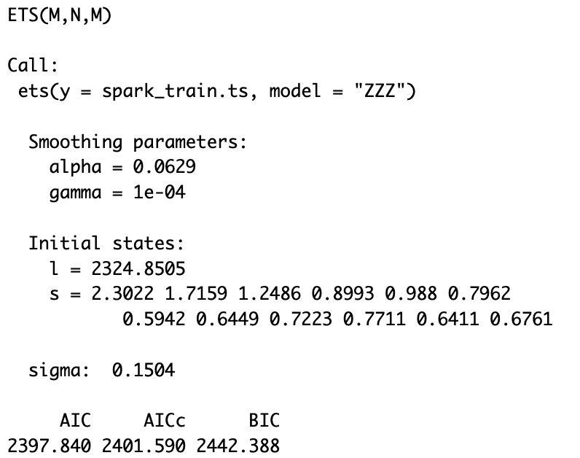

The below are accuracy metrics of the holt-winter model rounded to 3.

|  |  |  |
| --- | --- | --- |
| Model | RMSE | MAPE |
| Holt-Winter model | 346.055 | 11.791 |

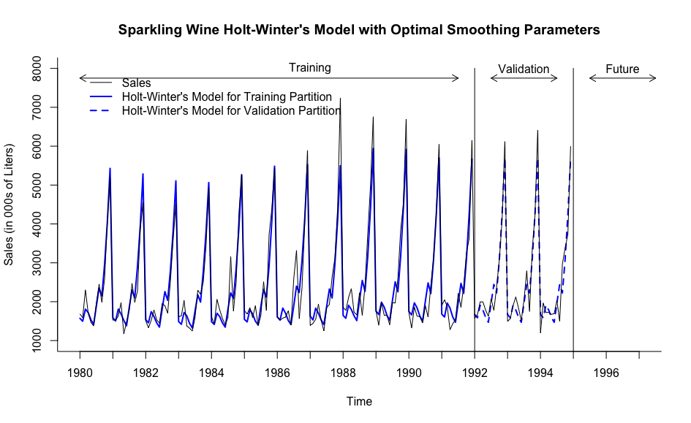

Above is the plot for the Holt-winter model into Training Data and Validation data.

1. Auto ARIMA Model

Below is the output for the Auto ARIMA Model for the sparkling wine series.

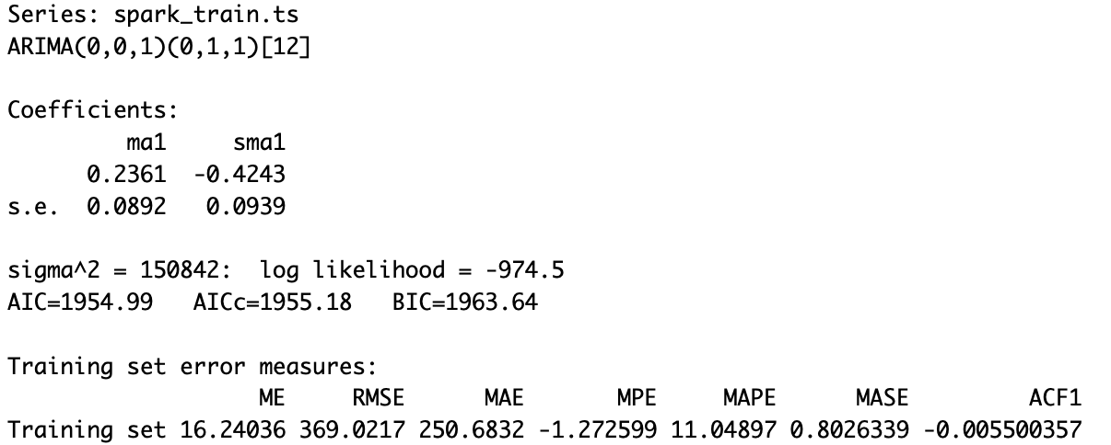

The sparkling wine series coefficients consist of a moving average lagged 1 period, and 1 seasonal moving average lagged 1 with values of: 0.2361, -0.4243 respectively.

|  |  |  |
| --- | --- | --- |
| Auto ARIMA for sparkling wine | | |
| p | 0 | order 0 autoregressive model |
| d | 0 | order 0 differencing to remove linear trend |
| q | 1 | order 1 moving average (MA1) model for error lags. |
| P | 0 | order 0 autoregressive model for seasonality. |
| D | 1 | order 1 differencing to remove linear trend |
| Q | 1 | order 1 moving average (SMA1) model for error lags |
| m | [12] | For monthly seasonality. |

The below are accuracy metrics of the Auto-ARIMA model rounded to 3.

|  |  |  |
| --- | --- | --- |
| Model | RMSE | MAPE |
| Auto-ARIMA model | 327.009 | 11.961 |

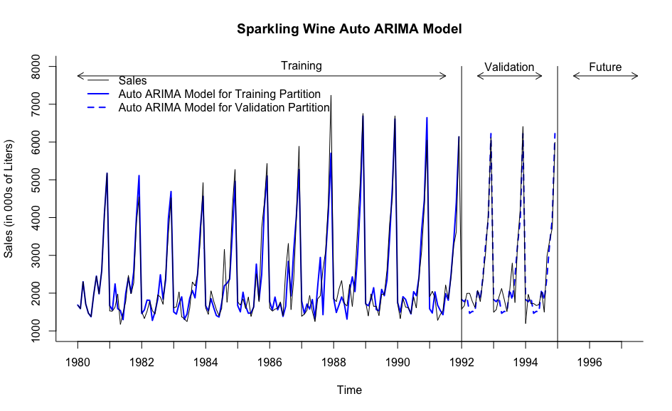

Above is the plot for the Auto-ARIMA model into Training Data and Validation data.

1. Two level with linear trend + seasonality regression and AR(1) model for regression residuals into Training Data.

Linear trend and seasonality regression.

Below is the output for the Linear trend and seasonality regression for the sweet white wine series.

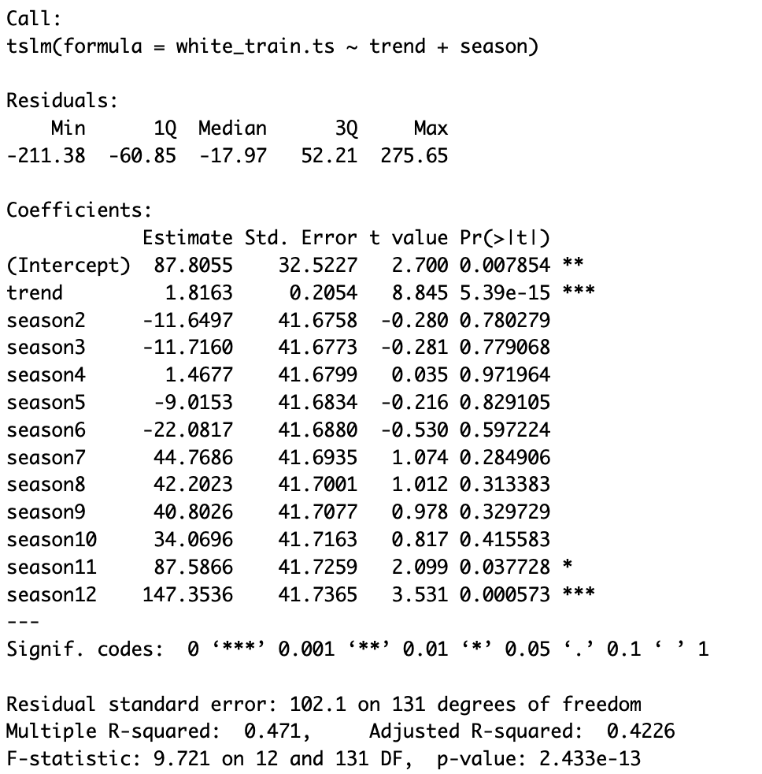

For the sweet white wine , the model above represents a regression model with linear trend and seasonality. The model is statistically significant since the F-Statistic p-value is very high (5.539e- 15), much lower than an alpha of 5%. The R-Square of the model is 47.1%, it is closer to 100% meaning it is not statistically significant. The adjusted R-square of the model is 42.26%. These predictors are all not significant since their p-values are higher than an alpha of 5%.

Below is the output for the AR(1) Model for the sweet white wine series.

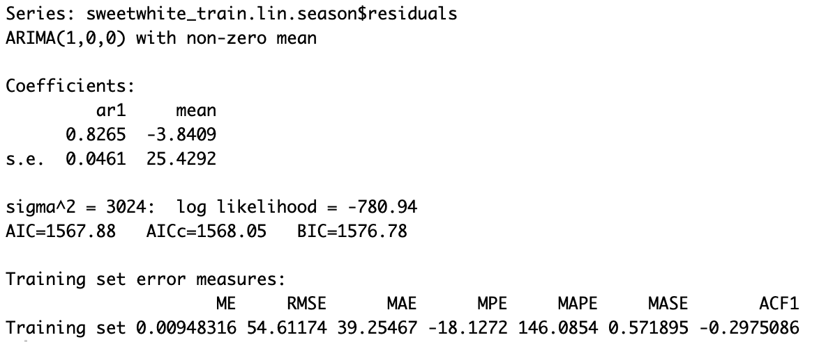

For the sweet white wine series, the AR(1) function was used to create an autoregressive model using the residuals for the regression with linear trend and seasonality. The model coefficient for AR1 model is 0.8265 and model intercept is the mean value of 0.0461.

Below is a compiled summary of the spa wine series autocorrelation charts representing the training residuals and the training residuals of residuals.

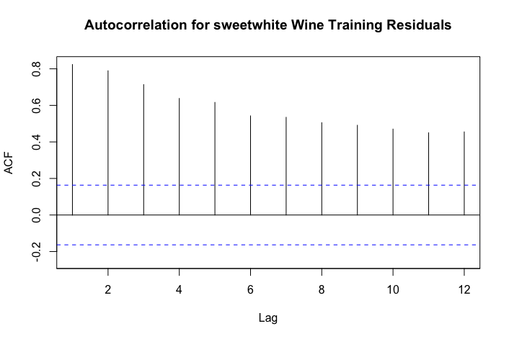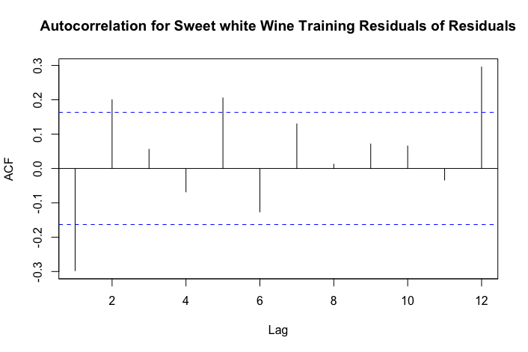

A table of validation data regression forecast, AR(1) forecast and combined forecast for sparkling wine is presented in figure-4 of the appendix.

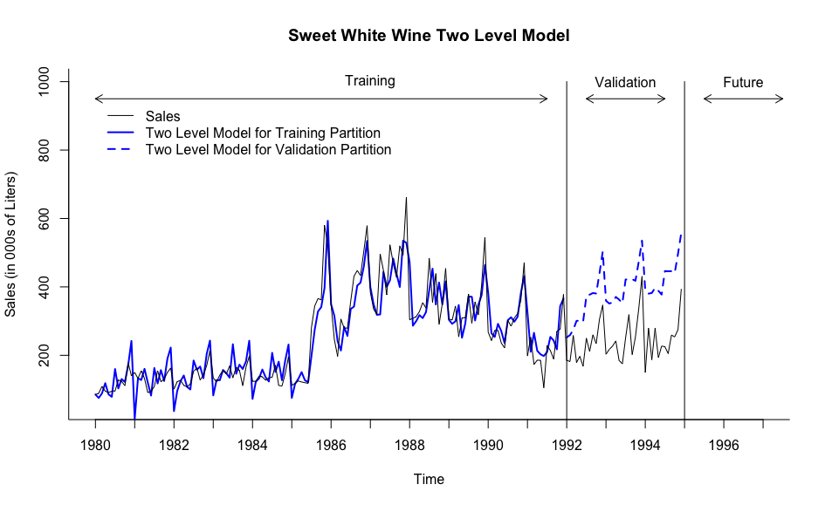

Above is the plot of sweet white wine for the two level model with linear trend + seasonality regression and AR(1) model for regression residuals into Training Data and Validation data. As we can see from the plot, This model doesn’t really understand what to do with the trend. This model is not a good predictor for this data set.

Below are the accuracies rounded to 2 using the function accuracy() in R

|  |  |  |
| --- | --- | --- |
| Model | RMSE | MAPE |
| Two level model forecast | 157.32 | 66.32 |
| Seasonal Naive forecast | 87.26 | 21.94 |
| Naive forecast | 80.30 | 22.27 |

1. Holt-Winters Model.

Below is the output for the Holt-Winter Model for the sparkling wine series.

The following summary represents the values of the smoothers of the Holt-Winters Model. Holt-Winters Models selected a model with multiplicative error, no trend and multiplicative seasonality with Smoothing parameters alpha of 0.6008 and gamma of 1e-04.

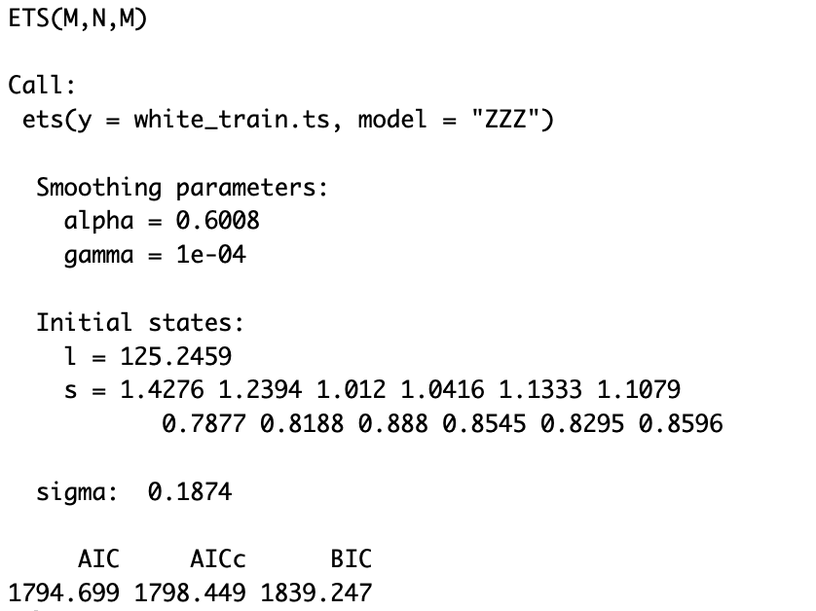

The below are accuracy metrics of the Holt-Winter model rounded to 3.

|  |  |  |
| --- | --- | --- |
| Model | RMSE | MAPE |
| Holt-Winter model | 37.918 | 13.351 |

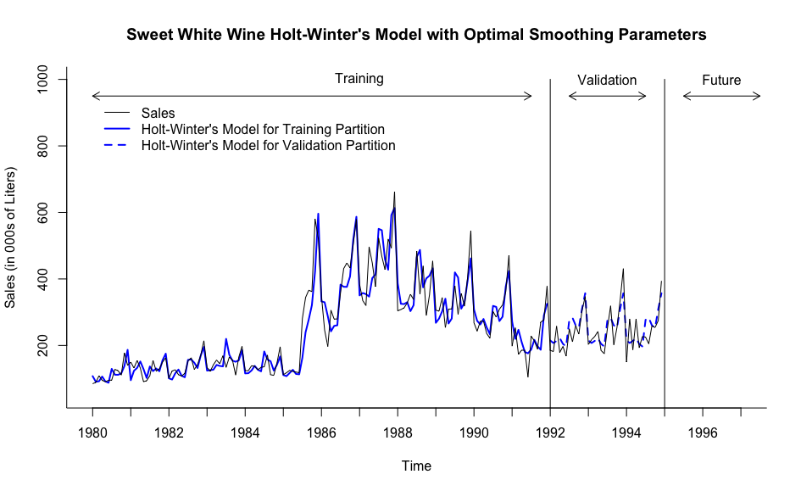

Above is the plot for the Holt-Winter model into Training Data and Validation data.

1. Auto ARIMA Model

Below is the output for the Auto ARIMA Model for the sparkling wine series.

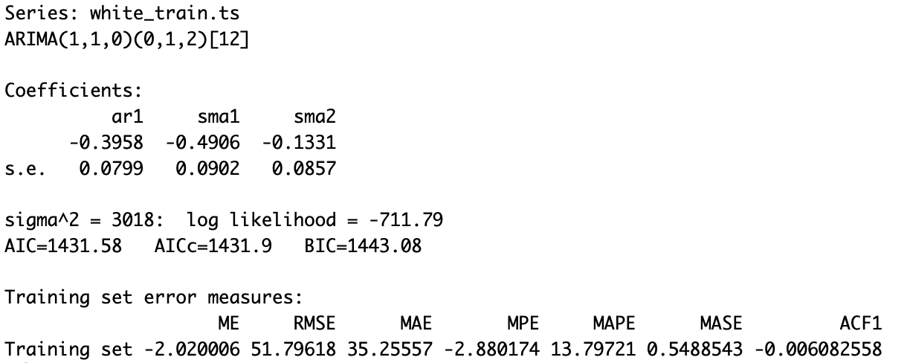

The sweet white wine series coefficients consist of a AR-1 coefficient, moving average lagged 1 period, and 2 seasonal moving average lagged 1 with values of: -0.3958,-0.4906, -0.1331 respectively.

|  |  |  |
| --- | --- | --- |
| Auto ARIMA for Sweet white wine | | |
| p | 1 | order 1 autoregressive model |
| d | 1 | order 1 differencing to remove linear trend |
| q | 0 | order 0 moving average (MA1) model for error lags. |
| P | 0 | order 0 autoregressive model for seasonality. |
| D | 1 | order 1 differencing to remove linear trend |
| Q | 2 | order 2 moving average (SMA1) model for error lags |
| m | [12] | For monthly seasonality. |

The below are accuracy metrics of the Auto-ARIMA model rounded to 3.

|  |  |  |
| --- | --- | --- |
| Model | RMSE | MAPE |
| Auto-ARIMA model | 120.043 | 45.721 |

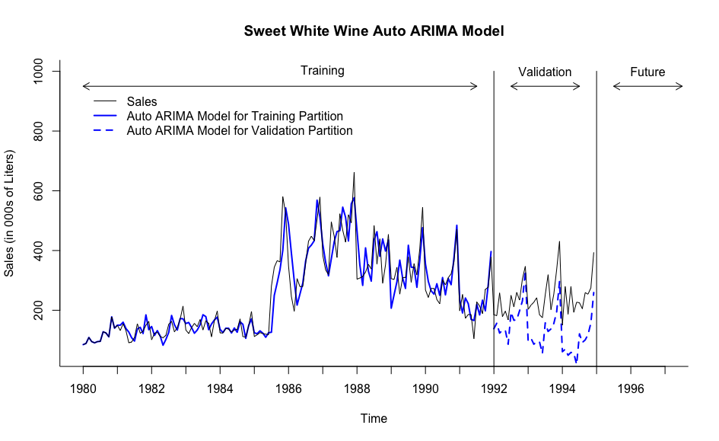

Above is the plot for the Auto-ARIMA model into Training Data and Validation data. Again, this model is a bad predictor for the dataset. Any unknown spikes introduced into the training data set causes the model to miscalculate the validation section.

**Step 8: Implement Forecast**

**Forecasting for Future Periods.**

**Red Wine**

1. Two level forecast with linear trend + seasonality regression and Trailing MA forecast model for Entire Data Set.

Below is the output for the Linear trend and seasonality regression for the red wine series for entire data.

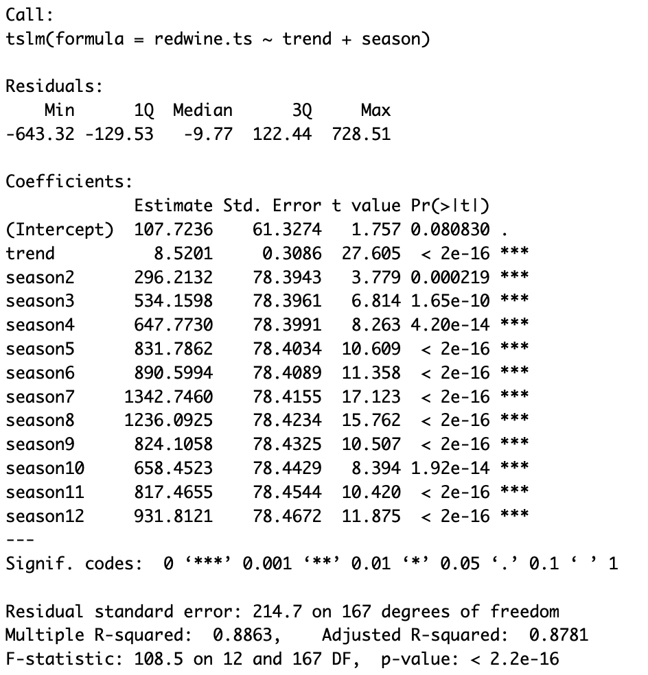

For the Red wine wine , the model above represents a regression model with linear trend and seasonality. The model is statistically significant since the F-Statistic p-value is very low (2e- 16), much lower than an alpha of 5%. The R-Square of the model is 88.63%, it is closer to 100% meaning it is not statistically significant. The adjusted R-square of the model is 87.81%. These predictors are all significant since their p-values are lower than an alpha of 5%.

Below is the forecast for trailing MA residuals for future 12 periods.

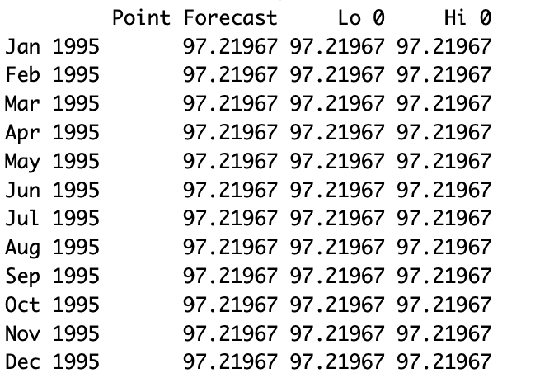

To improve the regression model with linear trend and seasonality, a trailing moving average was used to forecast residuals from the model. These components were then combined to create a two-level model which was used to predict the next 12 periods for the red wine series.

A table of future data regression forecast, MA residuals forecast and combined forecast for red wine wine for 1995 is presented below.

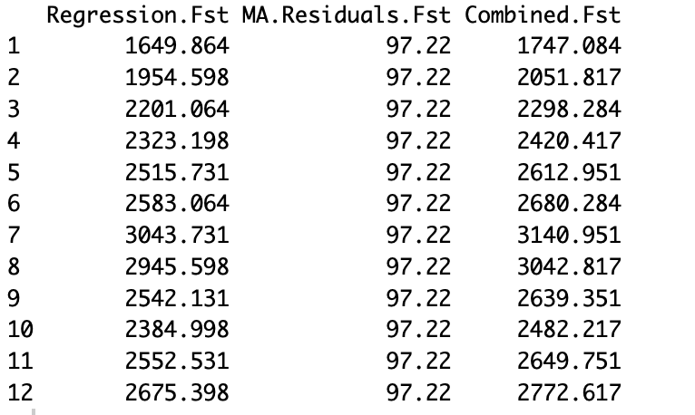

Below are the accuracies rounded to 2 using the function accuracy() in R

|  |  |  |
| --- | --- | --- |
| Model | RMSE | MAPE |
| Linear trend and seasonality | 206.79 | 11.26 |
| Two level model forecast | 171.22 | 9.11 |
| Seasonal Naive forecast | 270.78 | 12.26 |

1. Holt-Winters Model for Entire data.

Below is the output for the Holt-Winter Model for the Red wine wine series.

The following summary represents the values of the smoothers of the Holt-Winters Model. Holt-Winters Models selected a model with multiplicative error, additive trend and multiplicative seasonality with Smoothing parameters alpha of 0.1541, beta of 1e-04 and gamma of 1e-04.

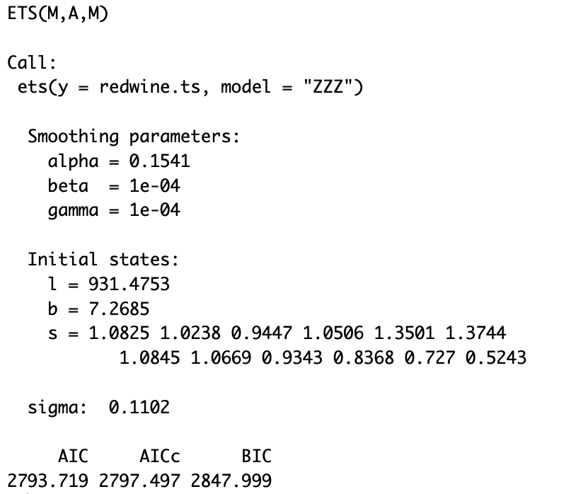

Future forecast of holt-winter model is presented in figure 5 of the appendix.

1. Auto ARIMA Model for Entire Data

Below is the output for the Auto ARIMA Model for the Red wine wine series.

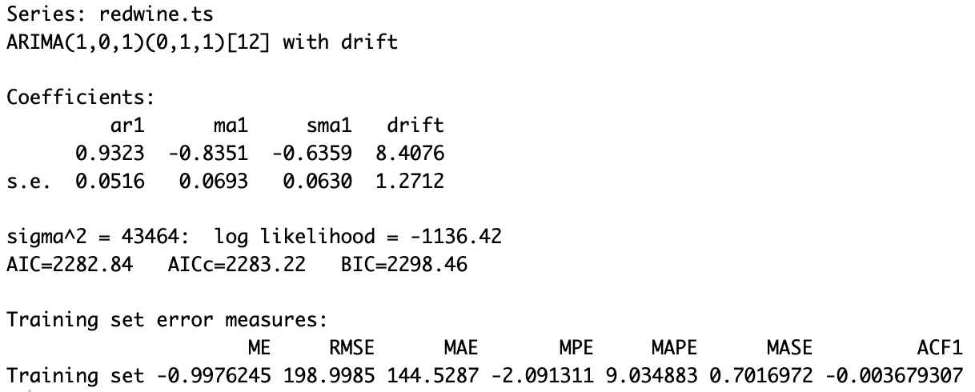

The sweet white wine series coefficients consist of a AR-1 coefficient, moving average lagged 1 period, and 1 seasonal moving average lagged 1 with values of: 0.9323, -0.8351, -0.6359 respectively.

|  |  |  |
| --- | --- | --- |
| Auto ARIMA for Red wine | | |
| p | 1 | order 1 autoregressive model |
| d | 0 | order 0 differencing to remove linear trend |
| q | 1 | order 1 moving average (MA1) model for error lags. |
| P | 0 | order 0 autoregressive model for seasonality. |
| D | 1 | order 1 differencing to remove linear trend |
| Q | 1 | order 1 moving average (SMA1) model for error lags |
| m | [12] | For monthly seasonality. |

Future forecast of Auto ARIMA model is presented in figure 6 of the appendix.

Accuracies Comparisons of Seasonal Naive, Holt-Winter Model and Auto ARIMA model.

|  |  |  |
| --- | --- | --- |
| Model | RMSE | MAPE |
| Seasonal Naive forecast | 270.78 | 12.262 |
| Holt-Winter model | 187.31 | 8.361 |
| Auto ARIMA model | 198.99 | 9.035 |

**Sparkling Wine**

1. Two level forecast with linear trend + seasonality regression and Trailing MA forecast model for Entire Data Set.

Below is the output for the Linear trend and seasonality regression for the sparkling wine series for entire data.

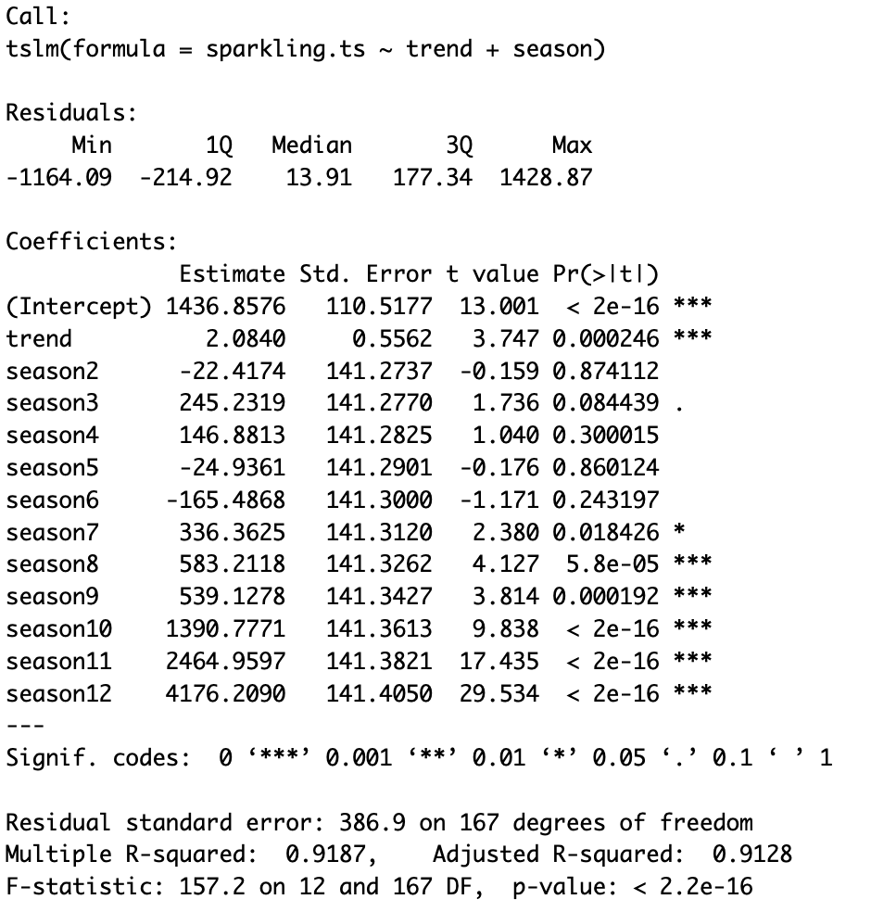

For the Sparkling wine wine , the model above represents a regression model with linear trend and seasonality. The model is statistically significant since the F-Statistic p-value is very low (2e- 16), much lower than an alpha of 5%. The R-Square of the model is 91.87%, it is closer to 100% meaning it is statistically significant. The adjusted R-square of the model is 91.28%. These predictors are all significant since their p-values are lower than an alpha of 5%.

Below is the forecast for trailing MA residuals for future 12 periods.

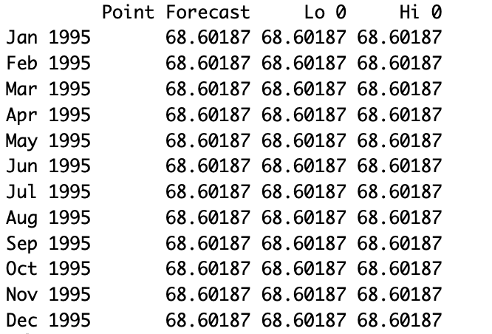

To improve the regression model with linear trend and seasonality, a trailing moving average was used to forecast residuals from the model. These components were then combined to create a two-level model which was used to predict the next 12 periods for the red wine series.

A table of future data regression forecast, MA residuals forecast and combined forecast for sparkling wine wine for 1995 is presented below.

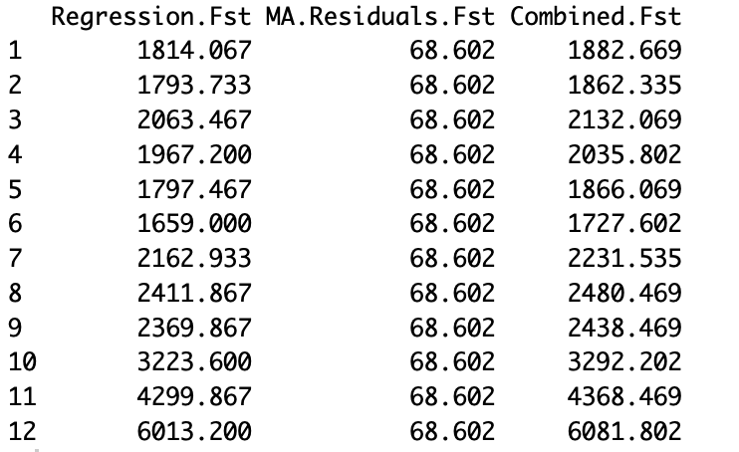

Below are the accuracies rounded to 2 using the function accuracy() in R

|  |  |  |
| --- | --- | --- |
| Model | RMSE | MAPE |
| Linear trend and seasonality | 372.65 | 11.63 |
| Two level model forecast | 311.84 | 11.28 |
| Seasonal Naive forecast | 429.52 | 13.85 |

1. Holt-Winters Model for Entire data.

Below is the output for the Holt-Winter Model for the Sparkling wine wine series.

The following summary represents the values of the smoothers of the Holt-Winters Model. Holt-Winters Models selected a model with multiplicative error, no trend and multiplicative seasonality with Smoothing parameters alpha of 0.0588 and gamma of 1e-04.

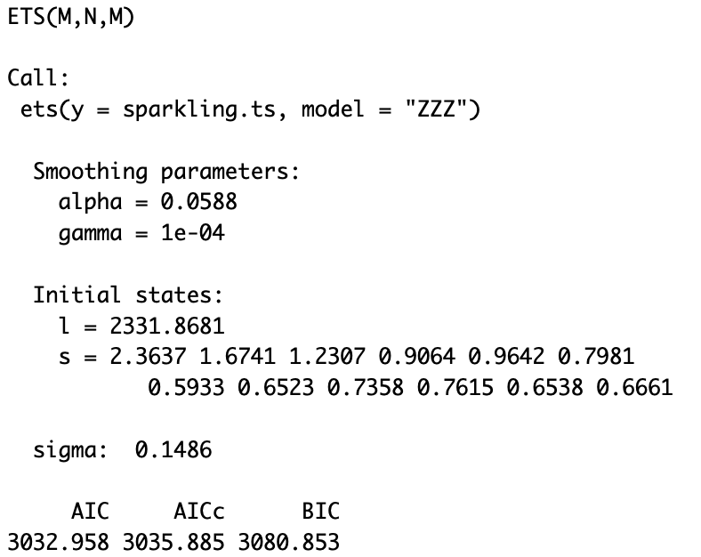

Future forecast of holt-winter model is presented in figure 7 of the appendix.

1. Auto ARIMA Model for Entire Data

Below is the output for the Auto ARIMA Model for the Red wine wine series.

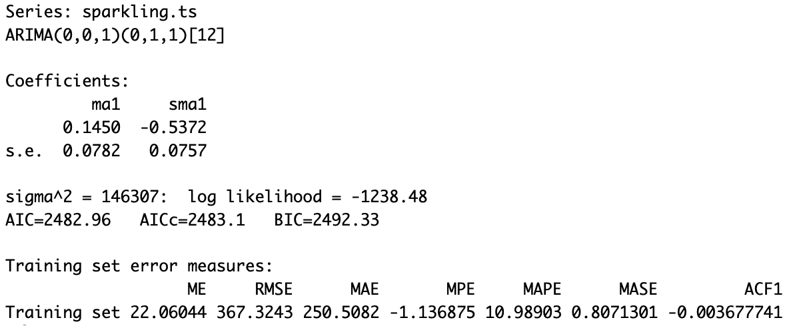

Future forecast of Auto ARIMA model is presented in figure 8 of the appendix.

The sweet white wine series coefficients consist of a moving average lagged 1 period, and 1 seasonal moving average lagged 1 with values of: 0.1450, -0.5372 respectively.

|  |  |  |
| --- | --- | --- |
| Auto ARIMA for Red wine | | |
| p | 0 | order 0 autoregressive model |
| d | 0 | order 0 differencing to remove linear trend |
| q | 1 | order 1 moving average (MA1) model for error lags. |
| P | 0 | order 0 autoregressive model for seasonality. |
| D | 1 | order 1 differencing to remove linear trend |
| Q | 1 | order 1 moving average (SMA1) model for error lags |
| m | [12] | For monthly seasonality. |

Accuracies Comparisons of Seasonal Naive, Holt-Winter Model and Auto ARIMA model.

|  |  |  |
| --- | --- | --- |
| Model | RMSE | MAPE |
| Seasonal Naive forecast | 429.52 | 13.85 |
| Holt-Winter model | 355.79 | 11.37 |
| Auto ARIMA model | 367.32 | 10.98 |

**Sweet white Wine**

1. Two level forecast with linear trend + seasonality regression and Trailing MA forecast model for Entire Data Set.

Below is the output for the Linear trend and seasonality regression for the sweet white wine series for entire data.

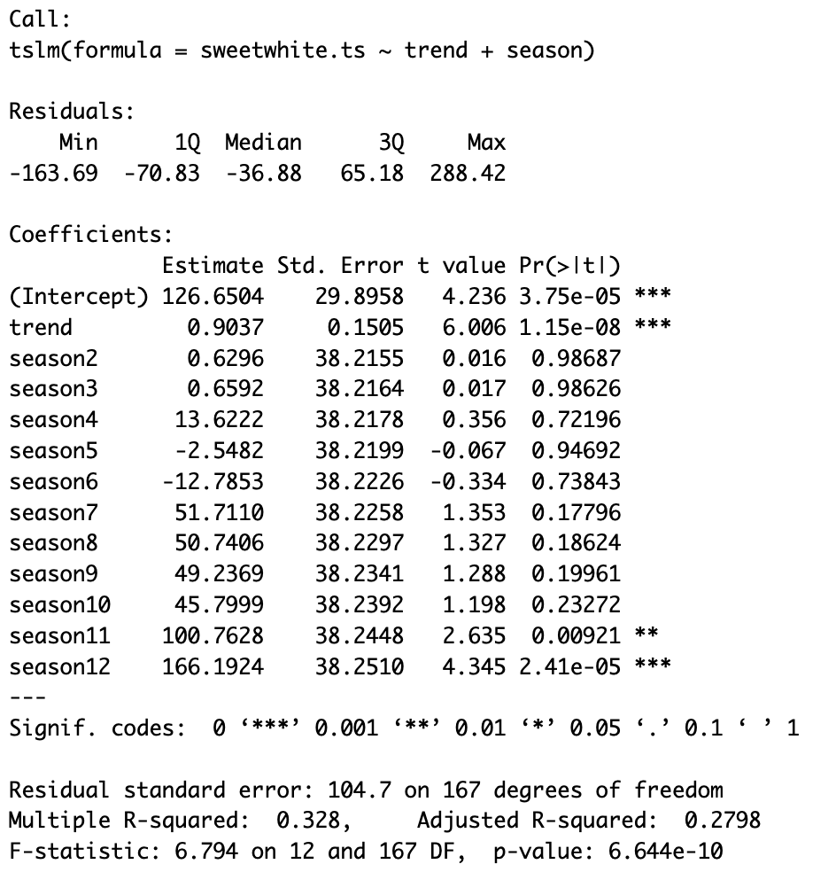

For the Sparkling wine wine , the model above represents a regression model with linear trend and seasonality. The model is statistically significant since the F-Statistic p-value is very low (1.15e- 8), much lower than an alpha of 5%. The R-Square of the model is 32.8%, it is not closer to 100% meaning it is not statistically significant. The adjusted R-square of the model is 27.98%. These predictors are all not significant since their p-values are higher than an alpha of 5%.

Below is the forecast for trailing MA residuals for future 12 periods.

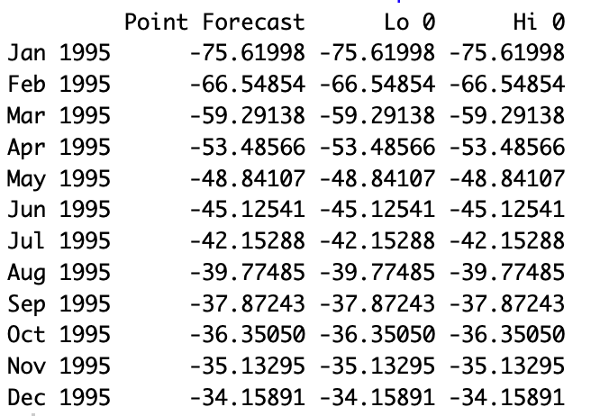

To improve the regression model with linear trend and seasonality, a trailing moving average was used to forecast residuals from the model. These components were then combined to create a two-level model which was used to predict the next 12 periods for the red wine series.

A table of future data regression forecast, MA residuals forecast and combined forecast for red wine wine for 1995 is presented below.

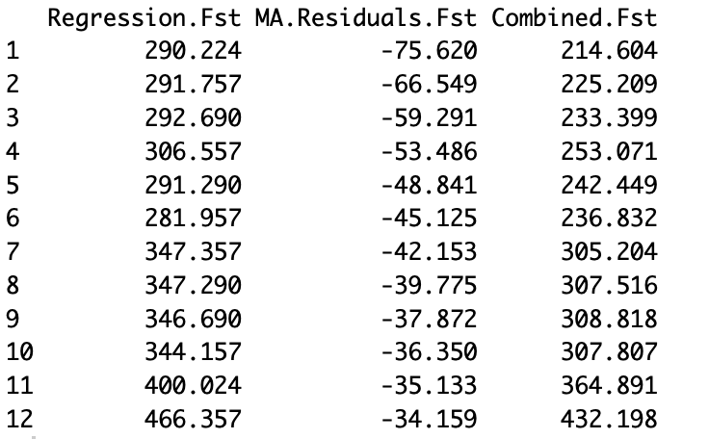

Below are the accuracies rounded to 2 using the function accuracy() in R

|  |  |  |
| --- | --- | --- |
| Model | RMSE | MAPE |
| Linear trend and seasonality | 100.80 | 35.97 |
| Two level model forecast | 38.73 | 14.04 |
| Seasonal Naive forecast | 87.26 | 21.94 |

1. Holt-Winters Model for Entire data.

Below is the output for the Holt-Winter Model for the Sweet white wine wine series.

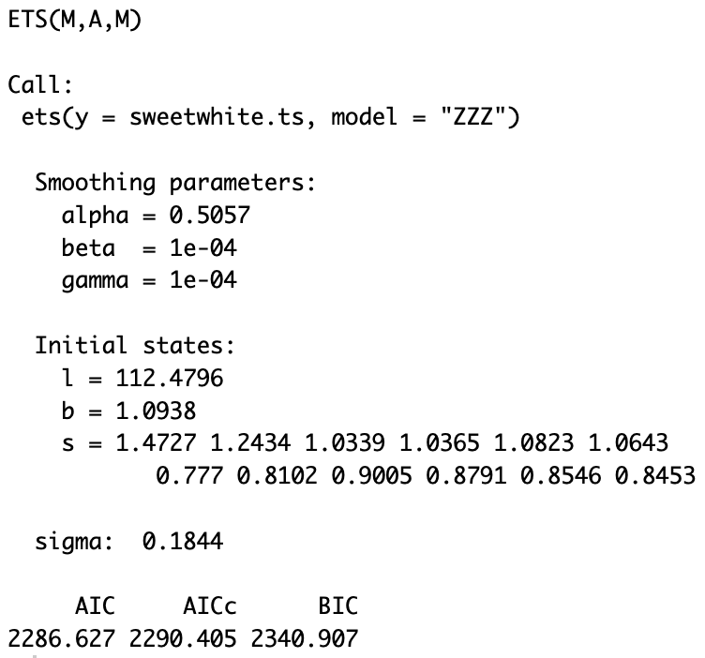

The following summary represents the values of the smoothers of the Holt-Winters Model. Holt-Winters Models selected a model with multiplicative error, additive trend and multiplicative seasonality with Smoothing parameters alpha of 0.5057, beta of 1e-04 and gamma of 1e-04.

Future forecast of Holt-Winter model is presented in figure 9 of the appendix.

1. Auto ARIMA Model for Entire Data

Below is the output for the Auto ARIMA Model for the Red wine wine series.

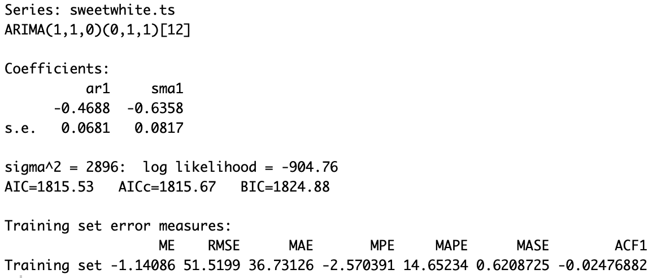

The Sweet White Wine series coefficients consist of a AR(1) lagged 1 period, and 1 seasonal moving average lagged 1 with values of: -0.4688, -0.6358 respectively.

|  |  |  |
| --- | --- | --- |
| Auto ARIMA for Red Wine | | |
| p | 1 | order 1 autoregressive model |
| d | 1 | order 1 differencing to remove linear trend |
| q | 0 | order 0 moving average (MA0) model for error lags. |
| P | 0 | order 0 autoregressive model for seasonality. |
| D | 1 | order 1 differencing to remove linear trend |
| Q | 1 | order 1 moving average (SMA1) model for error lags |
| m | [12] | For monthly seasonality. |

Future forecast of Auto ARIMA model is presented in figure 10 of the appendix.

Accuracies Comparisons of Seasonal Naive, Holt-Winter Model and Auto ARIMA model.

|  |  |  |
| --- | --- | --- |
| Model | RMSE | MAPE |
| Seasonal Naive forecast | 87.26 | 21.94 |
| Holt-Winter model | 44.83 | 13.59 |
| Auto ARIMA model | 51.79 | 13.79 |

**Conclusion**

Comparing the accuracies of the models for the different types of wine, it seems that the best model for our Australian Wines data set would have to be the Holt-Winters Model. The Holt-Winters model consistently placed in either the first or second place when comparing the accuracies of models. When it did take second place, the model only lost by less than one MAPE and a couple RMSE. Having such a close margin between the top two allows us to choose the model that was accurate across all three different types of wines. Focusing specifically on the Sweet White wine time series, we see how well models do well to predict unknown circumstances. The Sweet White Wine time series was the only “unusual” time series in this project with an usual spike in 1985 then a small decline to a more level amount. The other time series were much more consistent in their visual design. The Holt-Winters model with the exponential smoothing shows how helpful it is to focus on the newest data more than the older data in the time series. The auto ARIMA model and two level linear model especially were awful predictors of the validation set of the sweet white wine. The limitations of this model would have to be the long term predictability of the future forecasts. While this model isn’t special in that regard, these models should be updated every 6 months or sooner for more accurate predictions.

**Appendix**

**figure-1:**

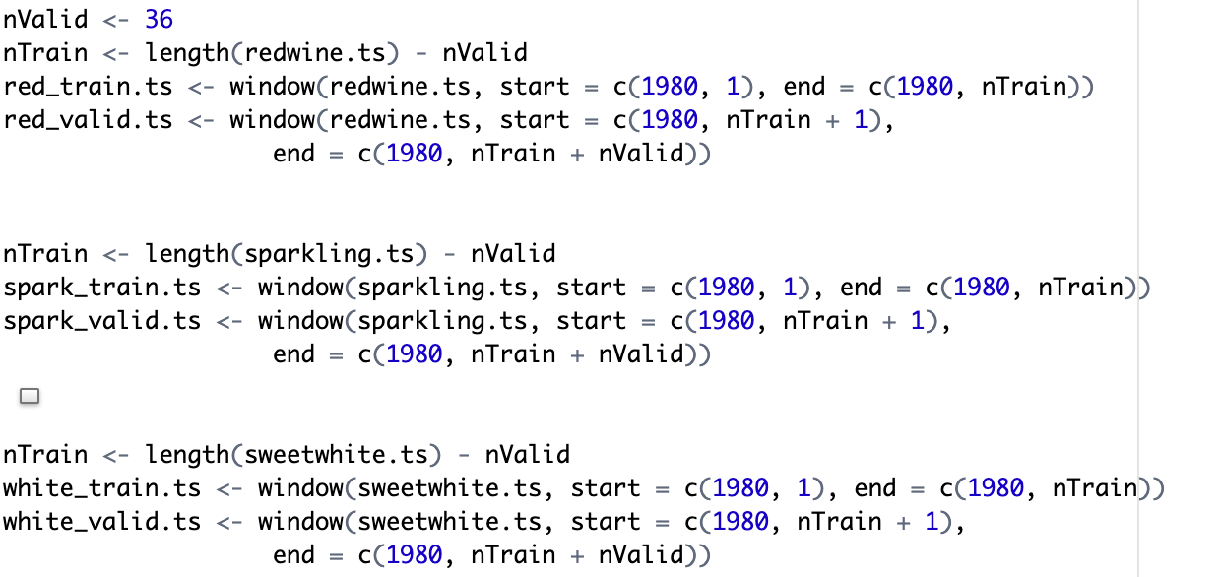

**figure-2:**

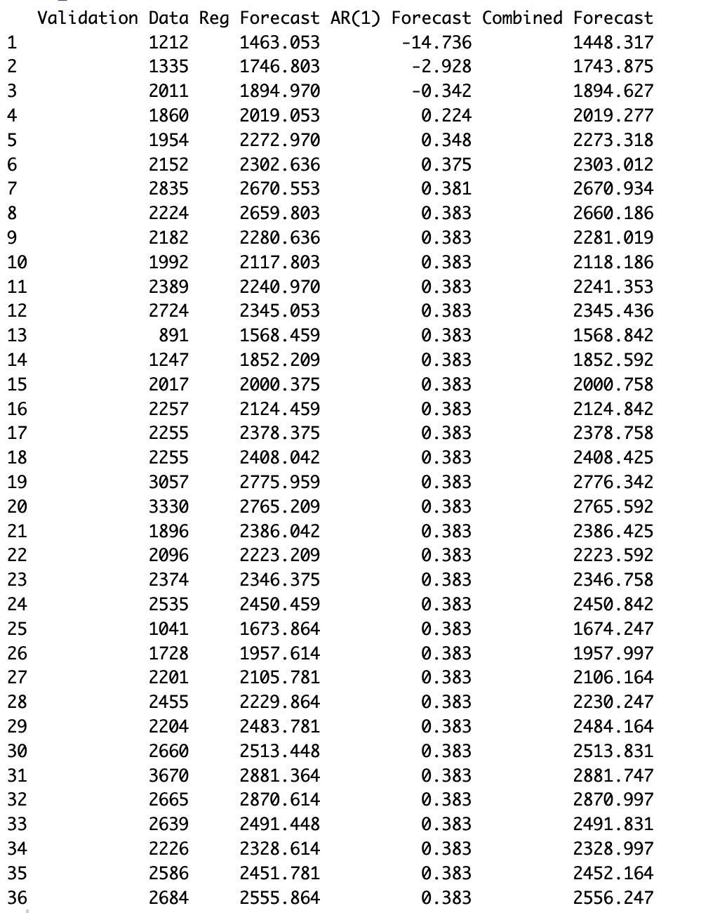

**figure-3:**

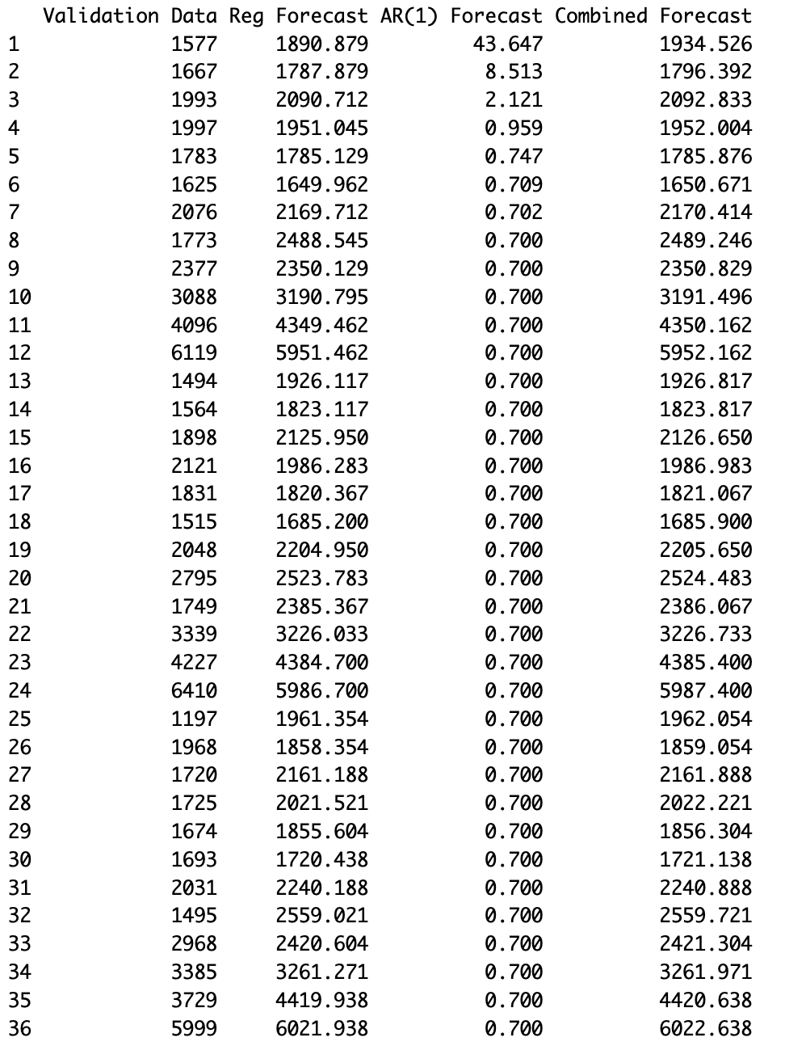

**figure-4:**

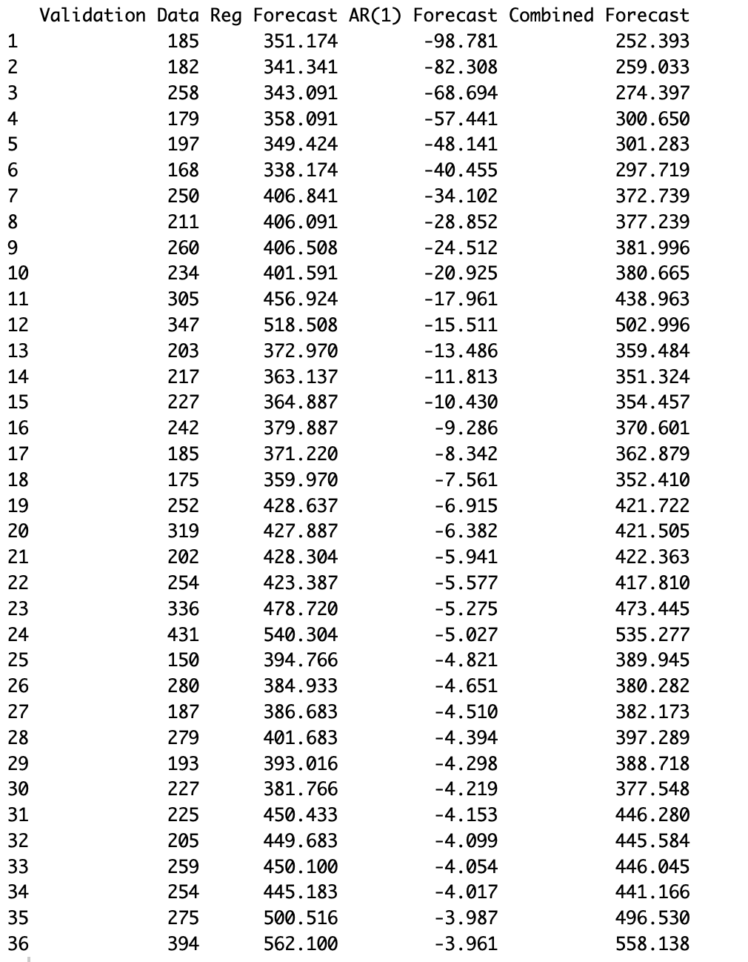

**figure-5:**

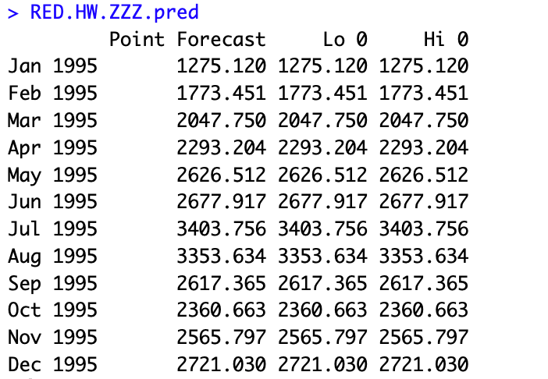

**figure-6:**

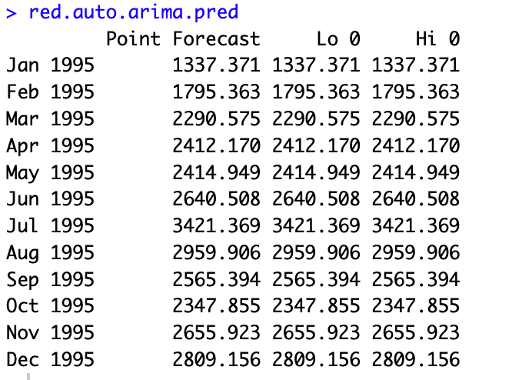

**figure-7:**

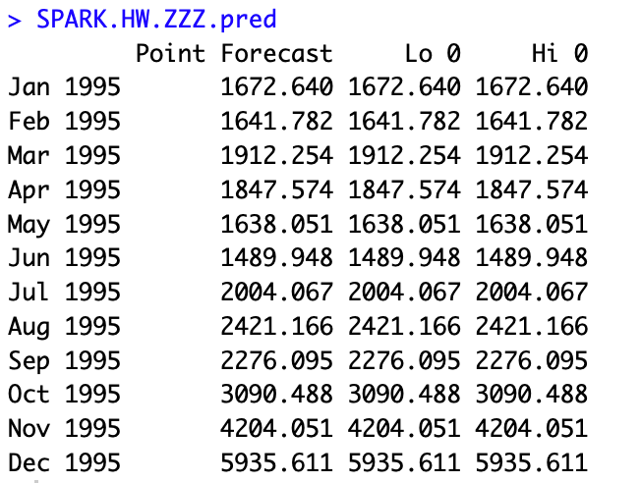

**figure-8:**

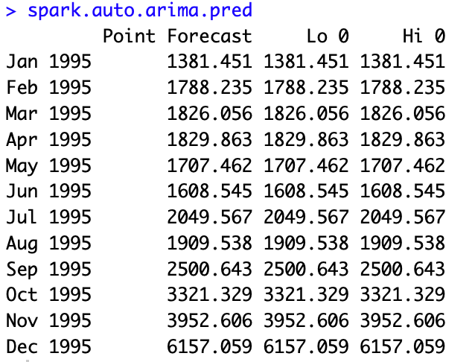

**figure-9:**

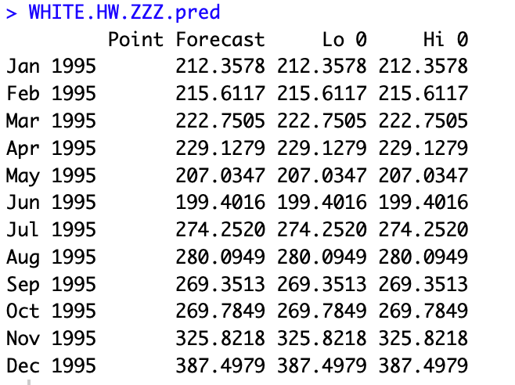

**figure-10:**

